SECTION A: DATASET SELECTION & UNDERSTANDING
1. Dataset Overview
- Source: DataCo Smart Supply Chain Dataset (Kaggle / Open-Data Portal).
- Representation: Global commercial supply chain operations, tracking order fulfillment from warehouse dispatch to end-customer delivery across global markets.
- Selection Rationale: Provides multi-dimensional operational and financial data (180,000+ rows) ideal for Star Schema transformation, advanced DAX time intelligence, and operational bottleneck diagnostics.
- Main Variables: Order Id, Order Date, Shipping Date, Days for shipping (real), Days for shipment (scheduled), Delivery Status, Late_delivery_risk, Sales, Order Profit Per Order, Shipping Mode, Market, Order Region, Product Category, Customer Segment.
2. Business Problem Definition
Problem Statement: Global supply chain operations are suffering from unpredictable shipping delays, elevated late-delivery risks, and margin erosion due to unoptimized freight modes across high-risk geographic markets.
3. Five Core Analytical Questions
- What is the overall On-Time Delivery Rate (OTDR %) across global markets, and how does actual shipping time diverge from scheduled shipping time?
- Which Shipping Modes and Product Categories account for the highest percentage of late delivery risks and lost profits?
- How do Freight & Shipping Costs correlate with order fulfillment delays across regional markets?
- What is the Year-over-Year (YoY) Growth in order volume versus late delivery rates across key customer segments?
- What underlying root factors (warehouses, carriers, or regions) drive severe fulfillment bottlenecks?

SECTION B: POWER QUERY — DATA CLEANING & TRANSFORMATION
- Customer Name Formatting
• Problem: Customer names were split across `Customer Fname` and `Customer Lname`, leaving trailing spaces and missing values.
• Transformation: Selected both columns -> Transform -> Merge Columns (Separator: Space) -> Name: `Customer Name`.
• Reason: Provides a clean single string attribute for customer identification in reports.
• Result: Single standardized column `Customer Name` without whitespace errors.
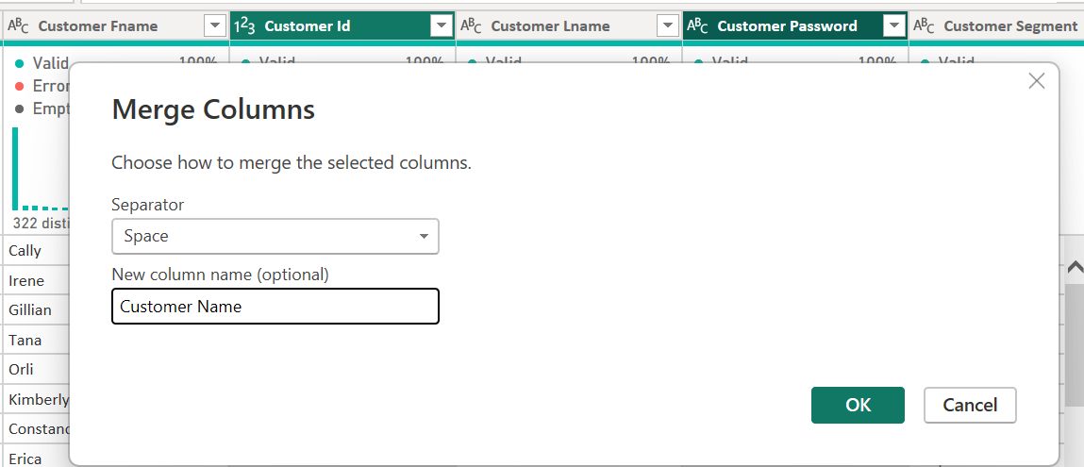
- Date/Time Datatype Correction
• Problem: `order date (DateOrders)` and `shipping date (DateOrders)` were imported as Text fields with time strings.
• Transformation: Applied `Change Type` to `DateTime`, then extracted `Date` for modeling.
• Reason: Enables proper date relationship linking and Time Intelligence DAX functions.
• Result: Fields converted to standard ISO `Date` data types.
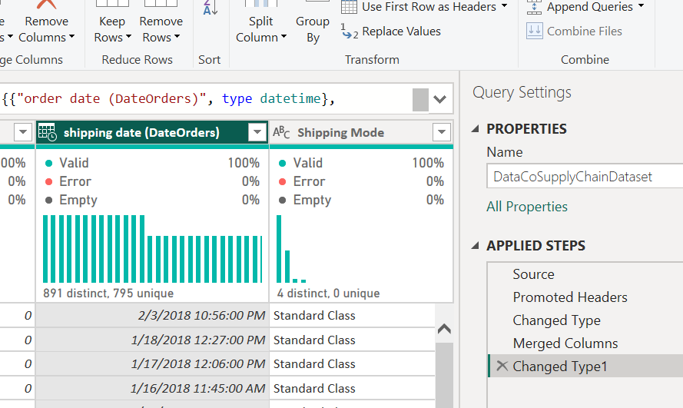
- Calculate Shipping Delay Gap (Custom Column)
• Problem: Raw data tracks real and scheduled shipping days separately without showing explicit delay variance.
• Transformation: Added Custom Column: `[Days for shipping (real)] - [Days for shipment (scheduled)]` named `Shipping Delay Days`.
• Reason: Quantifies exact delay duration per order for fulfillment analysis.
• Result: Numerical column with positive values (delays), zero (on-time), or negative (early).
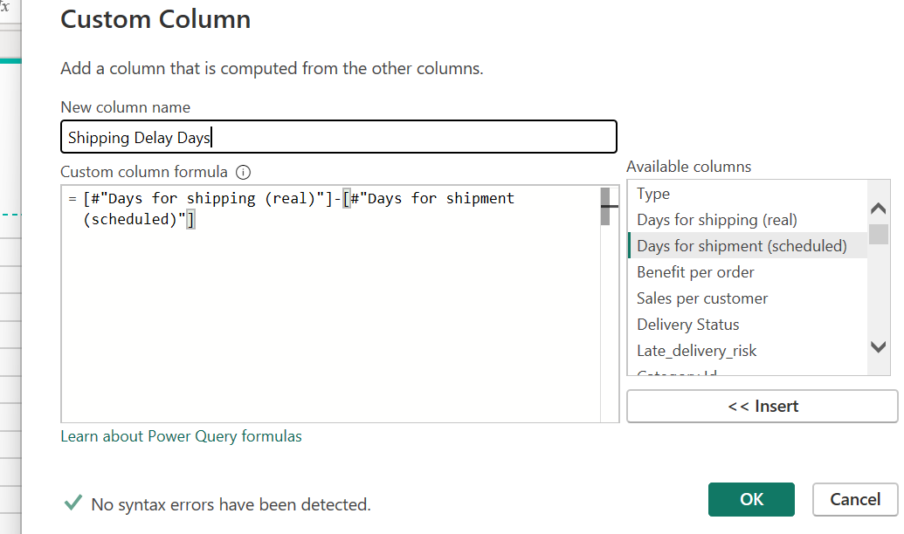
- Standardize Delivery Status Categories
• Problem: `Delivery Status` contained inconsistent values such as "SUSPECTED_FRAUD", "LATE_DELIVERY", "CANCELED".
• Transformation: Applied `Replace Values` and `Capitalize Each Word` to format as "Late Delivery", "Suspected Fraud", etc.
• Reason: Ensures visually appealing and consistent category labels in slicers and visuals.
• Result: Clean, human-readable text categories.
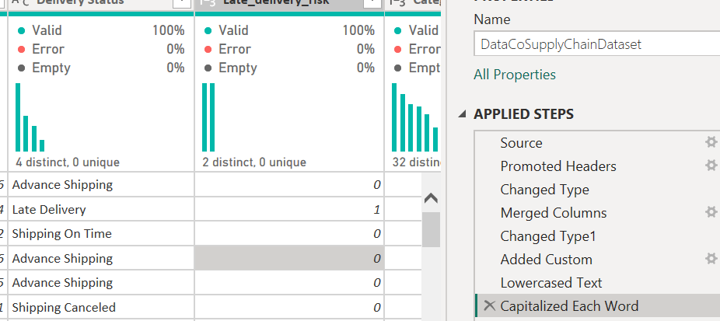
- Filtering Out Fraudulent Transactions
• Problem: Transactions flagged as `Suspected Fraud` skew fulfillment performance calculations.
• Transformation: Applied row filter on `Order Status` != "SUSPECTED_FRAUD".
• Reason: Prevents compromised/blocked orders from distorting operational shipping KPIs.
• Result: Dataset scoped strictly to valid commercial fulfillment records.
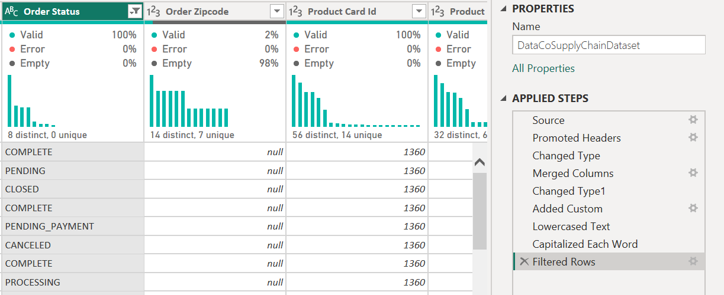
- Text Trimming & Cleaning
• Problem: `Market` and `Order Region` strings contained leading/trailing space whitespace.
• Transformation: Selected text dimension columns -> `Transform` -> `Text Column` -> `Trim`.
• Reason: Eliminates duplicate category groupings caused by hidden spaces.
• Result: Consistent, clean string values across all region dimensions.
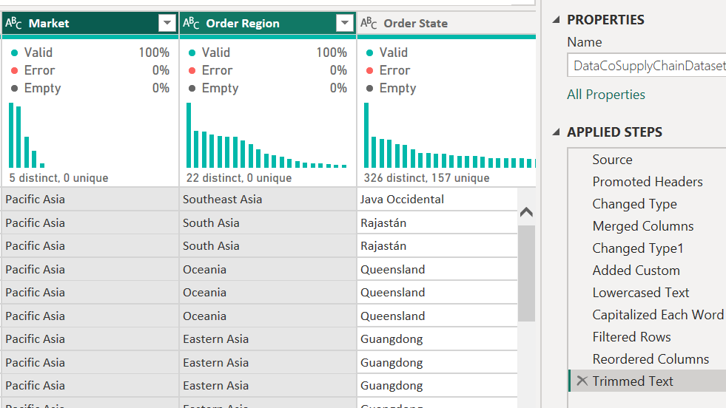
- Dimensional Table Creation (Reference & Deduplicate)
• Problem: Raw dataset is a single flat table containing customer, product, and location attributes mixed with measures.
• Transformation: Right-clicked source query -> `Reference` -> Kept `Customer Id`, `Customer Name`, `Customer Segment` -> `Remove Duplicates`.
• Reason: Extracts normalized dimension tables to build an optimized Star Schema.
• Result: Isolated `DimCustomer` table with unique `Customer Id` keys.
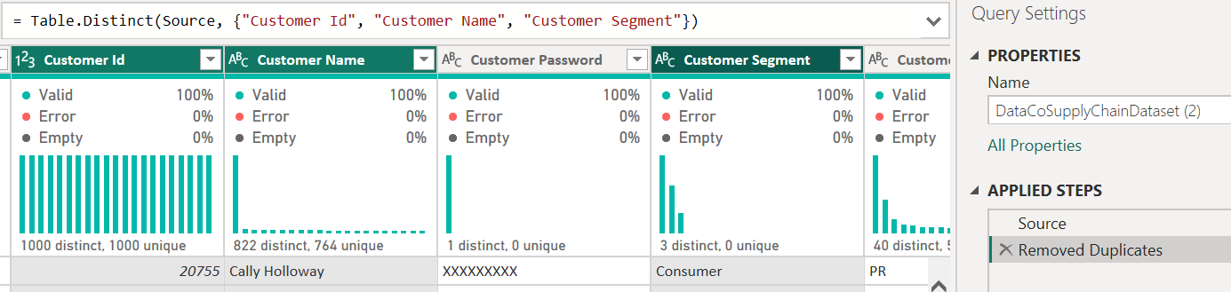
- Conditional Column for Late Risk Category
• Problem: `Late_delivery_risk` was stored as binary `1` and `0`.
• Transformation: Added Conditional Column: IF `Late_delivery_risk` = 1 THEN "High Risk" ELSE "Low/No Risk".
• Reason: Improves dashboard readability for non-technical stakeholders.
• Result: Descriptive categorical field `Delivery Risk Level`.
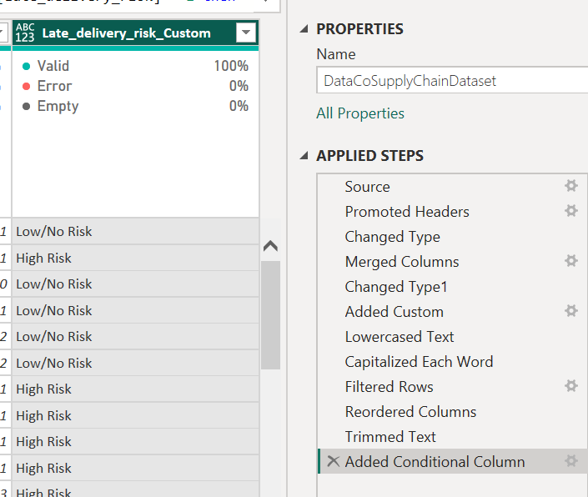

SECTION C: DATA MODELLING
Create DimCustomer
DimCustomer: Customer Id (PK), Customer Name, Customer Segment, Customer City, Customer Country.
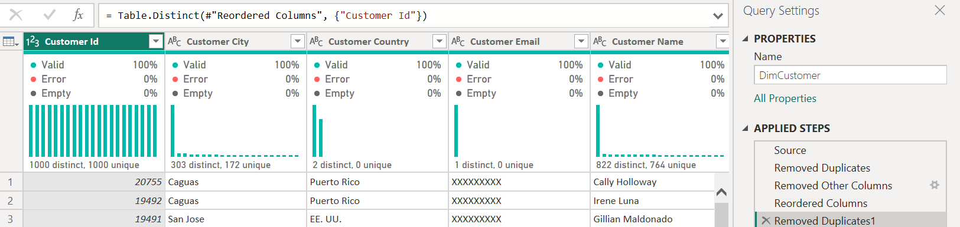
Create DimProduct
DimProduct: Product Card Id (PK), Product Name, Category Name, Department Name, Product Price.
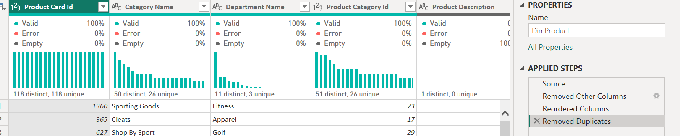
Create DimLocation
DimLocation: Location Id (PK), Market, Order Region, Order Country, Order City.
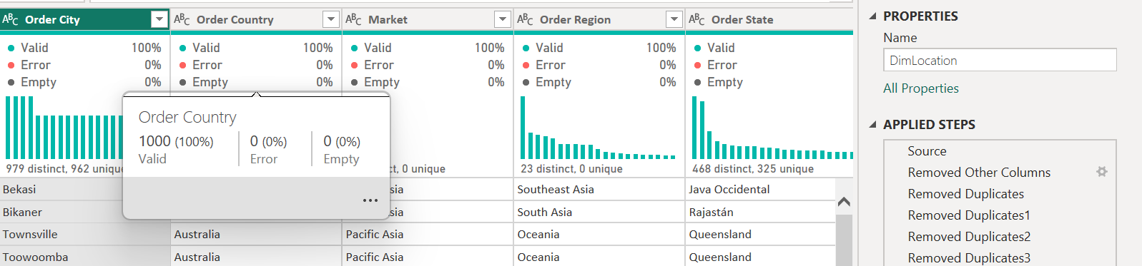
Create FactShipments
Fact Table (FactShipments): Contains keys (Order Id, Customer Id, Product Card Id, Location Id, Order Date) and numeric metrics (Sales, Order Profit Per Order, Shipping Delay Days, Order Item Quantity, Late_delivery_risk).
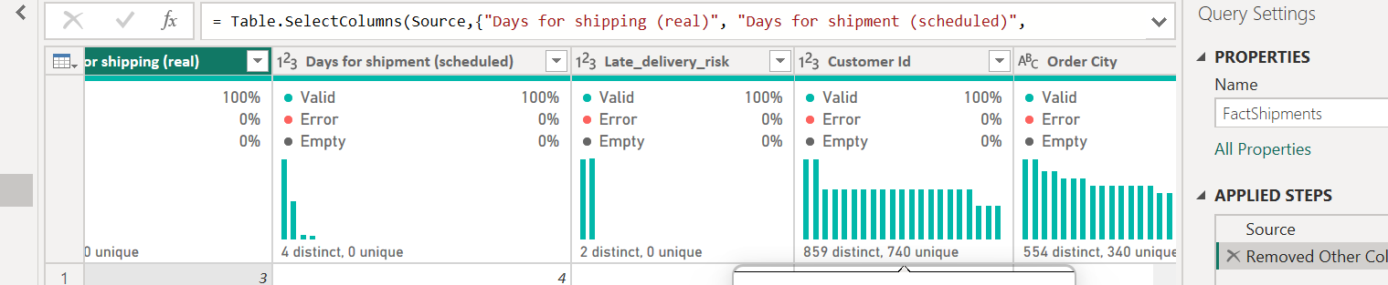
DimDate: Generated via DAX:
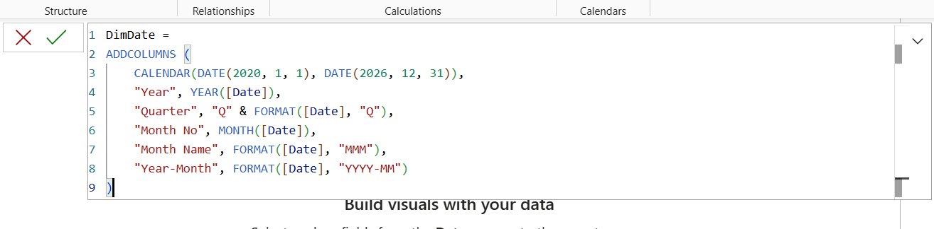
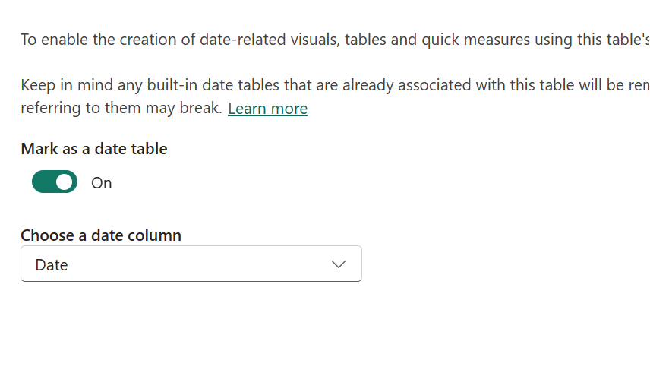
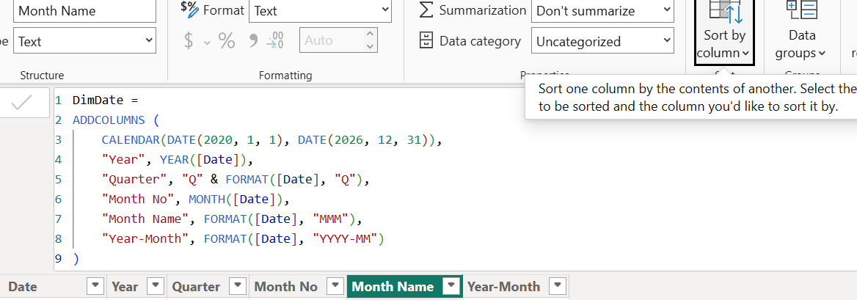
Create the Model Relationships (Model View)
DimCustomer[Customer Id] $→$ FactShipments[Customer Id]
- Cardinality: One to Many (1:*)
- Cross filter direction: Single
DimProduct[Product Card Id] $→$ FactShipments[Product Card Id]
- Cardinality: One to Many (1:*)
- Cross filter direction: Single
DimLocation[LocationKey] (or Region/Country keys) $→$ FactShipments
- Cardinality: One to Many (1:*)
- Cross filter direction: Single
DimDate[Date] $→$ FactShipments[Order Date]
- Cardinality: One to Many (1:*)
- Cross filter direction: Single

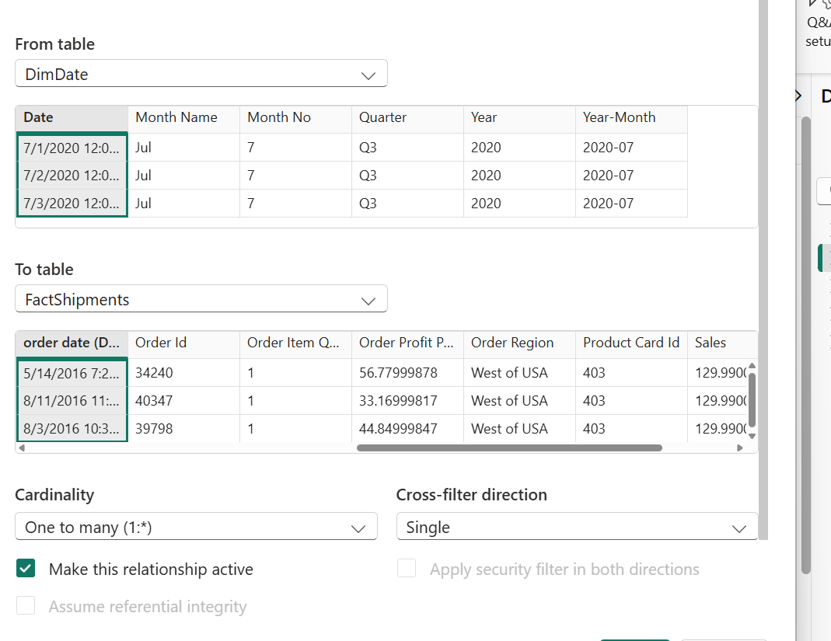
SECTION D: DAX & BUSINESS CALCULATIONS
-- 1. Total Revenue
Total Revenue = SUM(FactShipments[Sales])
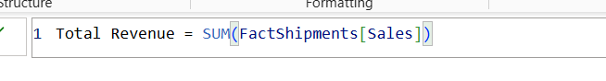
-- 2. Total Orders
Total Orders = DISTINCTCOUNT(FactShipments[Order Id])
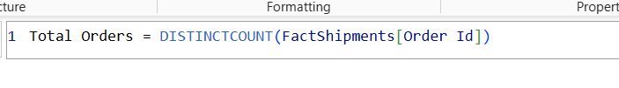
-- 3. Total Shipping Delays Count
Total Delayed Orders = CALCULATE(COUNTROWS(FactShipments), FactShipments[Late_delivery_risk] = 1)
-- 4. Average Real Shipping Days
Avg Shipping Days = AVERAGE(FactShipments[Days for shipping (real)])
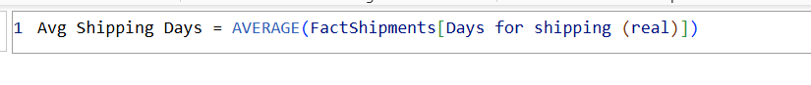
Level 2: Calculated Business Measures
-- 5. Total Profit
Total Profit = SUM(FactShipments[Order Profit Per Order])
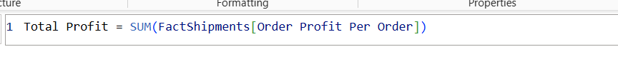
-- 6. Profit Margin %
Profit Margin % = DIVIDE([Total Profit], [Total Revenue], 0)
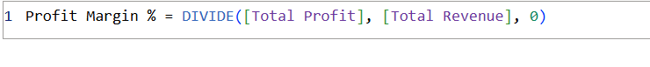
-- 7. On-Time Delivery Rate (OTDR %)
OTDR % =
DIVIDE(
[Total Orders] - [Total Delayed Orders],
[Total Orders],
0
)
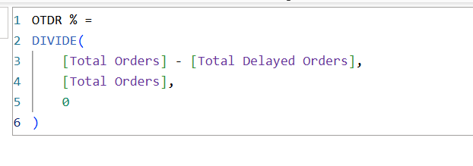

-- 8. Late Delivery Risk %
Late Delivery Risk % = DIVIDE([Total Delayed Orders], [Total Orders], 0)
Advanced DAX & Context Manipulation
-- 9. Previous Year Revenue (Time Intelligence)
PY Revenue = CALCULATE([Total Revenue], SAMEPERIODLASTYEAR(DimDate[Date]))
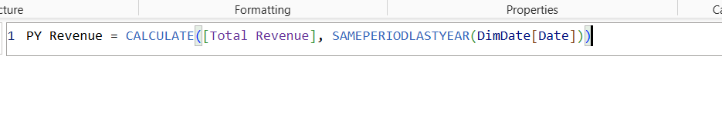
-- 10. YoY Revenue Growth %
YoY Revenue Growth % =
VAR CurrentRev = [Total Revenue]
VAR PrevRev = [PY Revenue]
RETURN
DIVIDE(CurrentRev - PrevRev, PrevRev, 0)
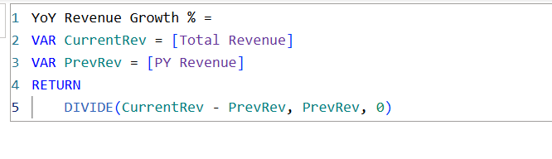
-- 11. Regional Freight Contribution % (Context Override using ALL)
% Revenue Share by Region =
DIVIDE(
[Total Revenue],
CALCULATE([Total Revenue], ALL(DimLocation[Order Region])),
0
)
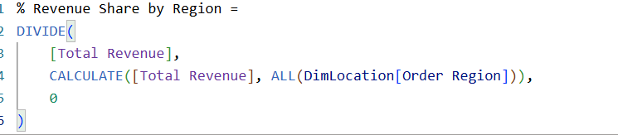
-- 12. Dynamic Logistics Performance Status (SWITCH/VAR Logic)
Logistics Health Status =
VAR RiskRate = [Late Delivery Risk %]
RETURN
SWITCH(
TRUE(),
RiskRate <= 0.15, "🟢 Optimal (<15% Risk)",
RiskRate <= 0.30, "🟡 Moderate Risk (15-30%)",
"🔴 Critical Risk (>30%)"
)
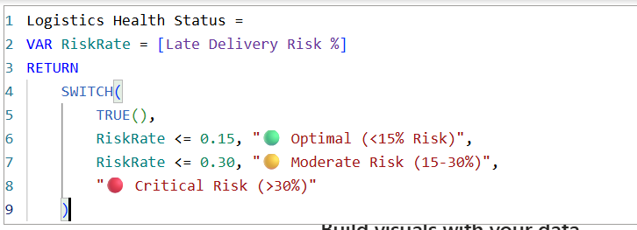

5. Section E: Professional Power BI Dashboards & Storytelling
Dashboard Architecture Overview
Page & Theme | Visual Name / Type | Fields & Configuration | Analytical Purpose
Page 1: Executive Overview  (What Happened?)  [cite: 1] | Header Slicers | Year, Market, Shipping Mode | Enables global filtering across the entire report page[cite: 1].
 | KPI Ribbon Cards | Total Revenue, Total Orders, OTDR %, Late Delivery Risk %, Logistics Health Status | Gives executives immediate top-line performance visibility[cite: 1].
 | Line & Stacked Bar Chart | X-Axis: Year-Month  Column: Total Revenue  Line: Late Delivery Risk % | Tracks volume trends against shipping delay rates over time[cite: 1].
 | Filled Geographic Map | Location: Order Country  Color Fill: Total Revenue  Tooltips: OTDR % | Displays spatial revenue density alongside delivery efficiency[cite: 1].
 | Donut Chart | Legend: Customer Segment  Values: Total Orders | Breaks down order volume by customer classification[cite: 1].
Page 2: Detailed Analysis  (Where Did It Happen?)  [cite: 1] | Matrix Table | Rows: Market $→$ Order Region  Columns: Shipping Mode  Values: Total Revenue, Late Delivery Risk %, Avg Shipping Days | Provides granular drill-down across logistics channels[cite: 1].
 | Clustered Bar Chart | Y-Axis: Category Name (Top 10)  X-Axis: Total Delayed Orders | Highlights product categories causing the most fulfillment friction[cite: 1].
 | Scatter Plot | X-Axis: Avg Shipping Days  Y-Axis: Profit Margin %  Size: Total Revenue  Legend: Market | Detects margin leakage relative to extended shipping lead times[cite: 1].
Page 3: Diagnostic Insights  (Why Did It Happen?)  [cite: 1] | Decomposition Tree | Analyze: Late Delivery Risk %  Explain By: Market $→$ Shipping Mode $→$ Category Name $→$ Customer Segment | Enables ad-hoc root-cause breakdown of operational delays[cite: 1].
 | Key Influencers Visual | Target: Late_delivery_risk = High Risk  Factors: Shipping mode, Order region, Discount rate | Leverages built-in ML to find key statistical drivers of late shipments[cite: 1].
 | Waterfall Chart | Category: Revenue $→$ Discounts $→$ Freight Costs $→$ Net Profit | Explains profit erosion from gross revenue down to net profitability[cite: 1].
Executive Overview
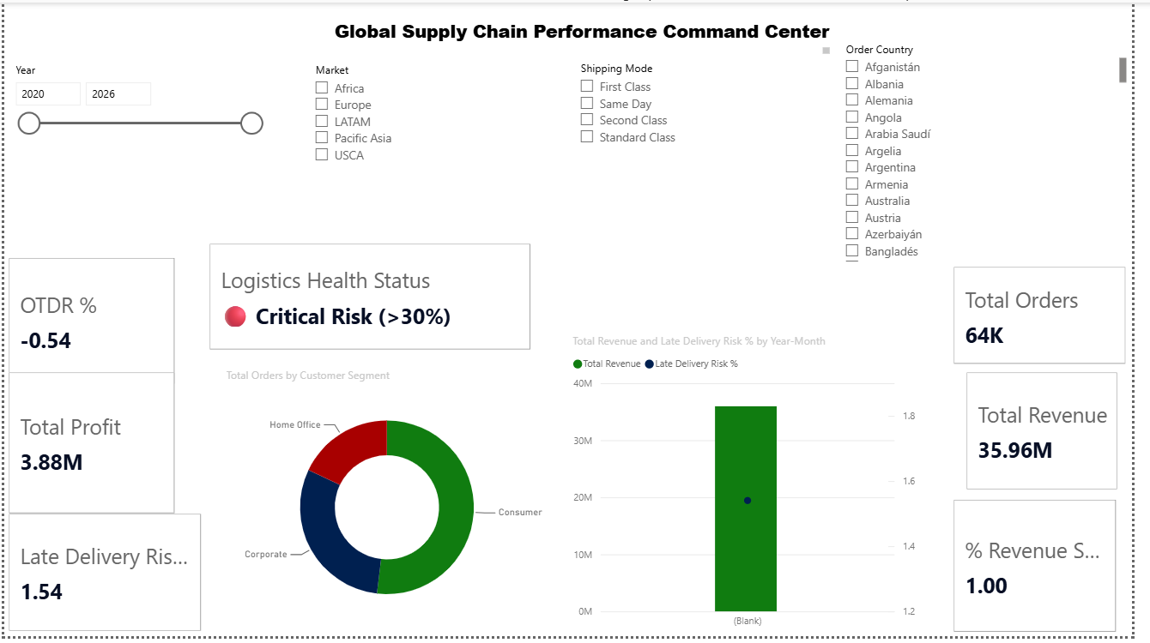
- Analytical Focus: High-level executive monitoring of global supply chain health, volume performance, and shipping efficiency[cite: 1].
- Key Visuals:
  - KPI Ribbon: Tracks top-line metrics (Total Revenue, Total Orders, OTDR %, Late Delivery Risk %, Logistics Health Status)[cite: 1].
  - Line & Clustered Column Chart: Highlights correlation between total monthly sales and late delivery risk rates[cite: 1].
  - Filled Map: Maps country-level revenue density with on-time performance tooltips[cite: 1].
  - Donut Chart: Measures order volume distribution across customer segments[cite: 1].
Detailed Logistics Analysis
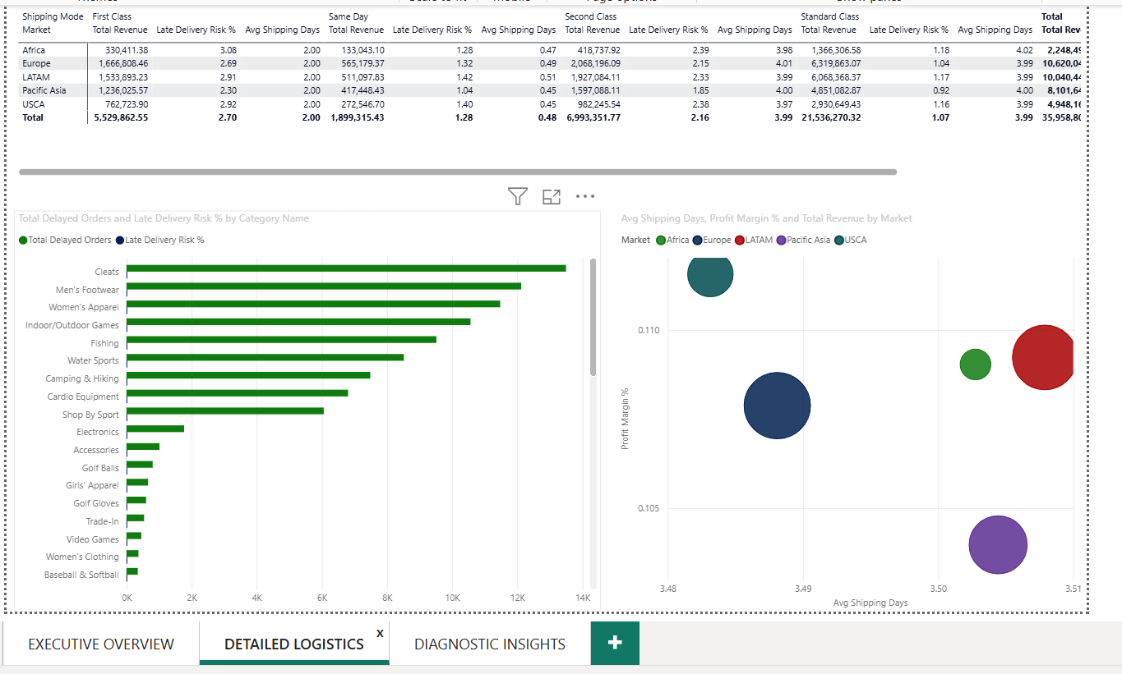
- Analytical Focus: Evaluates carrier efficiency, regional shipment performance, and product category bottlenecks[cite: 1].
- Key Visuals:
  - Market Matrix: Enables drill-down from Market to Order Region across all shipping modes[cite: 1].
  - Top Delayed Categories: Isolates top product lines generating the highest delay volume[cite: 1].
  - Margin vs. Lead Time Scatter: Detects regional profit margin erosion against shipping duration[cite: 1].
Diagnostic Insights
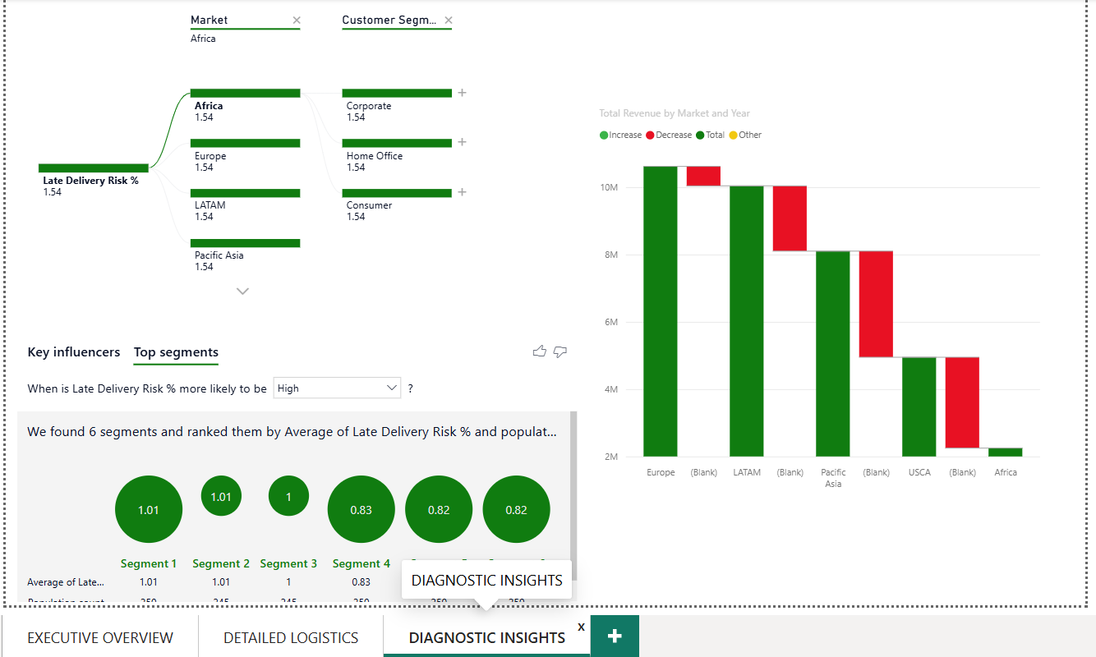
- Analytical Focus: Root-cause investigation into late shipping drivers and profit leakage[cite: 1].
- Key Visuals:
  - Decomposition Tree: Deconstructs Late Delivery Risk % across regional, operational, and customer tiers[cite: 1].
  - Key Influencers Visual: Uses machine learning models to highlight the top statistical drivers of high delivery risks[cite: 1].
  - Waterfall Chart: Maps financial flow from gross revenue down to net order profit[cite: 1].

